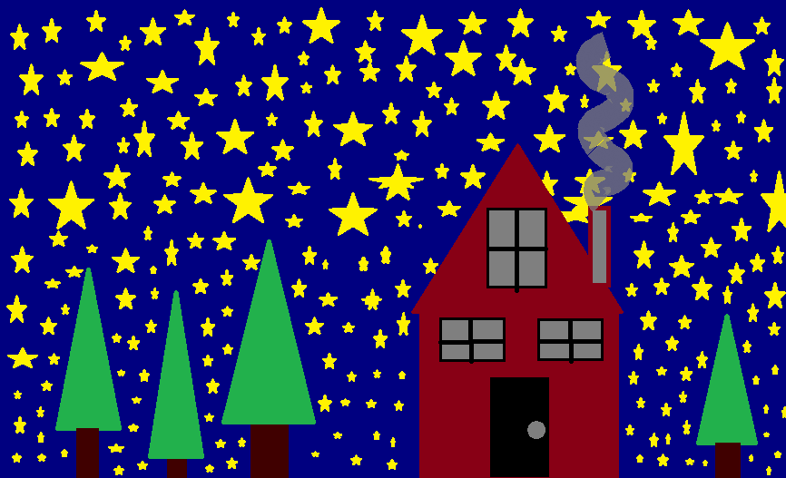
This is a picture of a starry night out in the country. It is fall and starting to get cold out so this family has started a fire in the fireplace for the first time this year!

